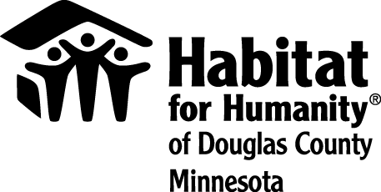

Authorization for Release of Information

I authorize representatives of Habitat for Humanity of Douglas County, Minnesota, Inc (“Habitat”) to discuss with representatives of the USDA Rural Development 502 Loan Program (“USDA”) information pertaining to my/our loan application as part of the Habitat for Humanity Partnership Housing Program.

You are hereby authorized to disclose to Habitat for Humanity of Douglas County any and all information requested. A photocopy of this authorization shall have the same effect as an original. This information will be kept in a secure place and will not be shared with unauthorized parties.

Printed Name Date

Signature Date

Printed Name Date

Signature Date

